

**Chic Lighting & Design Website**

**Documentation**

|  |  |
| --- | --- |
| **Authors** | **<C2111L><Group 1>** |
| **< Nam Nguyen Hoang >**  **< Son Nguyen Duc Hoang >**  **< Thanh Nguyen Tai >**  **< Tung Le Kim >** |
| **Date** | **03-Sep-2022** |
| **Instructor** | **< Toan Ngo Vinh >** |

Hanoi, September 3, 2022.

**Index**

[**1. Problem Definition 2**](https://docs.google.com/document/d/1Bn6tfKnmXLXzdZpC7ud9Kz_bAHrlldsU2VlOPLJrV-I/edit#heading=h.30j0zll)

[1.1. Problem Abstraction 2](https://docs.google.com/document/d/1Bn6tfKnmXLXzdZpC7ud9Kz_bAHrlldsU2VlOPLJrV-I/edit#heading=h.kkpwu04bzzsj)

[1.2. The Current System 2](https://docs.google.com/document/d/1Bn6tfKnmXLXzdZpC7ud9Kz_bAHrlldsU2VlOPLJrV-I/edit#heading=h.3znysh7)

[1.3. The Proposed System 2](https://docs.google.com/document/d/1Bn6tfKnmXLXzdZpC7ud9Kz_bAHrlldsU2VlOPLJrV-I/edit#heading=h.2et92p0)

[1.3.1. Boundaries of the System 2](https://docs.google.com/document/d/1Bn6tfKnmXLXzdZpC7ud9Kz_bAHrlldsU2VlOPLJrV-I/edit#heading=h.tyjcwt)

[1.3.2. Hardware and Software Requirements 2](https://docs.google.com/document/d/1Bn6tfKnmXLXzdZpC7ud9Kz_bAHrlldsU2VlOPLJrV-I/edit#heading=h.3dy6vkm)

[**2. Customer Requirements Specification 2**](https://docs.google.com/document/d/1Bn6tfKnmXLXzdZpC7ud9Kz_bAHrlldsU2VlOPLJrV-I/edit#heading=h.1t3h5sf)

[2.1. Users of the System 2](https://docs.google.com/document/d/1Bn6tfKnmXLXzdZpC7ud9Kz_bAHrlldsU2VlOPLJrV-I/edit#heading=h.4d34og8)

[2.2. System functions 2](https://docs.google.com/document/d/1Bn6tfKnmXLXzdZpC7ud9Kz_bAHrlldsU2VlOPLJrV-I/edit#heading=h.2s8eyo1)

[**3. System Designs 2**](https://docs.google.com/document/d/1Bn6tfKnmXLXzdZpC7ud9Kz_bAHrlldsU2VlOPLJrV-I/edit#heading=h.17dp8vu)

[3.1 Entity Relationship Diagram 2](https://docs.google.com/document/d/1Bn6tfKnmXLXzdZpC7ud9Kz_bAHrlldsU2VlOPLJrV-I/edit#heading=h.3rdcrjn)

[3.2 Database Design 3](https://docs.google.com/document/d/1Bn6tfKnmXLXzdZpC7ud9Kz_bAHrlldsU2VlOPLJrV-I/edit#heading=h.26in1rg)

[3.3 Sitemap 3](https://docs.google.com/document/d/1Bn6tfKnmXLXzdZpC7ud9Kz_bAHrlldsU2VlOPLJrV-I/edit#heading=h.lnxbz9)

[3.4 System functions design 3](https://docs.google.com/document/d/1Bn6tfKnmXLXzdZpC7ud9Kz_bAHrlldsU2VlOPLJrV-I/edit#heading=h.35nkun2)

[**4. Task sheet 3**](https://docs.google.com/document/d/1Bn6tfKnmXLXzdZpC7ud9Kz_bAHrlldsU2VlOPLJrV-I/edit#heading=h.1ksv4uv)

[**5. Validation Checklists 3**](https://docs.google.com/document/d/1Bn6tfKnmXLXzdZpC7ud9Kz_bAHrlldsU2VlOPLJrV-I/edit#heading=h.44sinio)

**1. Problem Definition**

**1.1. Problem Abstraction**

<Giới thiệu chung về dự án. Nêu Xuất xứ của dự án, lý do cần thiết xây dựng dự án>

In 1971, Chic Lighting & Design was operated. For today's eclectic environments, we provide one-of-a-kind lighting and accessories in the most beautiful traditional and sophisticated contemporary styles. An online store called Chic Lighting & Design specializes in LED lights, lamps, chandeliers, and pendant lighting. Crystal chandeliers, conventional chandeliers, contemporary chandeliers, glass pendant lights, industrial and vintage pendant lights, metal pendant lights, and many more are among the selections we provide.

**1.2. The Current System**

<Mô tả cách thức hoạt động của hệ thống hiện tại (nếu có). Nếu chưa có hệ thống hiện tại thì mô tả quy trình làm việc hiện tại khi chưa có ứng dụng CNTT>

Thesedays, our needs are expanding. The need for home decoration is also one of them. So gorgeous lights are great items to make our home more beautiful. However, traveling a lot or going far is what makes it difficult for us to find and buy light bulbs. Therefore, we "group 1" will build a chic and lighting website where people can shop online without having to move. We hope that this website will contribute to everyone with quality and beautiful light bulbs

**1.3. The Proposed System**

<Mô tả về hệ thống mà chúng ta sẽ xây dựng. Nêu rõ các chức năng cần có của hệ thống mới>

in this our project we build website with some functions as follows:

* Allows users to register for an account
* allow users to log into accounts
* Search product
* Add product to cart
* Send Feedback
* Edit account (retrieve password, change password)

***1.3.1. Boundaries of the System***

<Nêu rõ những giới hạn của hệ thống: khách hàng, đối tượng sử dụng. Phạm vi áp dụng, ...>

Due to the limitation of time, experience and knowledge, our website still has some disadvantages:

* can only apply COD
* no language change feature

***1.3.2. Hardware and Software Requirement***

**Hardware**

* Intel Core i3/i5 Processor or higher
* 8 GB RAM or above
* Color SVGA
* 500 GB Hard Disk space
* Mouse
* Keyboard

**Software**

Technologies to be used:

* Frontend: HTML5, CSS, Bootstrap, JavaScript,
* Backend: PHP
* Data Store: JSON files or TXT files

**2. Customer Requirements Specification**

**2.1. Users of the System**

2.1.1. Unregistered users:

* visit homepage
* visit the product page
* visit product detail page
* visit the about page

2.1.2. Registered users:

They can access all functions just like unregistered users. In

addition, they can use some additional functions:

* Add to cart, order
* send feedback
* change password and recover password

**2.2. System functions**

<Phân tích yêu cầu cho từng chức năng đã xác định ở phần 1.3. Mỗi chức năng cần theo cấu trúc như đã hướng dẫn: thông tin đầu vào, thông tin đầu ra, cách thức xử lý, dữ liệu cần lưu trữ>

2.2.1. Register

* Input: The users enter their information from the keyboard
* Process: The user's information will be inserted into the table in the database
* Output: The user's screen will switch to the home page

2.2.2. Login

* Input: The users enter their account name and password from the keyboard
* Process: If the correct username and password exist in the database, switch to the home page. Otherwise, error message will appear on screen
* Output: The user's screen will switch to the home page

2.2.3. Log out

* Input: The users click on the log out button
* Process: session will be terminated
* Output: The user's screen will switch to the home page

2.2.4. Feedback

* Input: The users enter their feedback
* Process: insert user’s feedback into database
* Output: The page will reload

2.2.5. Change Password

* Input: The users enter the old and new password
* Process: Update the table in database
* Output: Print the message of successful password change on the screen

2.2.6. Search

* Input: The users enter product name
* Process: Query into the database of matching product names
* Output: The user's screen will switch to the home page

2.2.7. Add to cart

* Input: The users click on the Add to Cart button
* Process: Insert into the table in database
* Output: Show the cart

**3. System Designs**

**3.1 Entity Relationship Diagram**

<Vẽ mô hình quan hệ thực thể. Nên sử dụng 1 chương trình vẽ chuyên nghiệp ví dụ Visio 2010>

**3.2 Database Design**

<Căn cứ dữ liệu đầu tiên, bảng dữ liệu thu thập được ở dạng chưa chuẩn hoá (UNF), nếu sử dụng dữ liệu đã chuẩn hoá sẵn cần nêu rõ lý do và nguồn tham khảo / lấy>

<Sơ đồ quan hệ giữa các bảng ở dạng chuẩn hoá 3NF, nếu phi chuẩn cần nêu rõ lý do>

<Mô tả chi tiết các bảng>

3.2.1. Table relationship

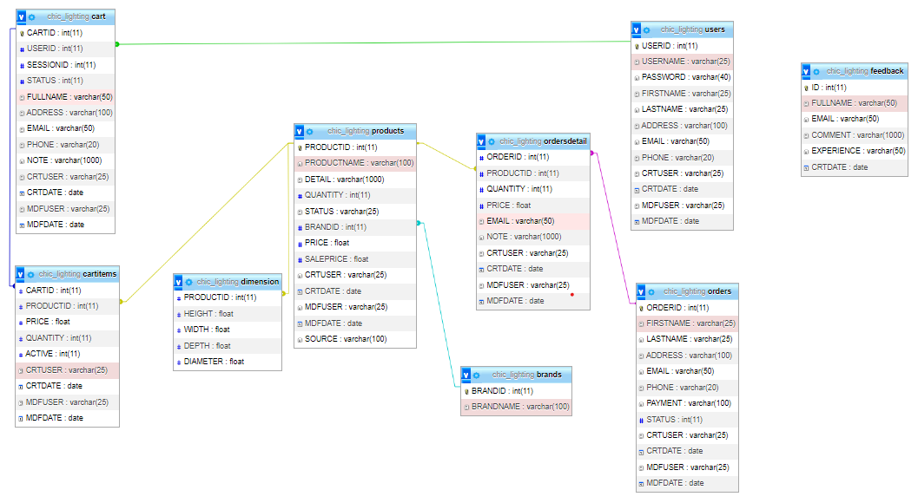

3.2.2. Table detail

3.2.2.1. brands



3.2.2.2. cart

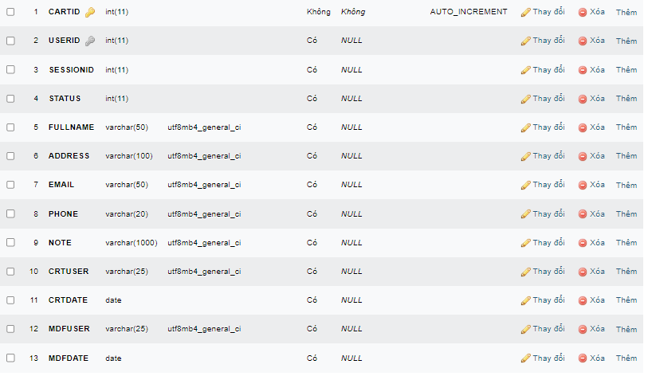

3.2.2.3. cartitems

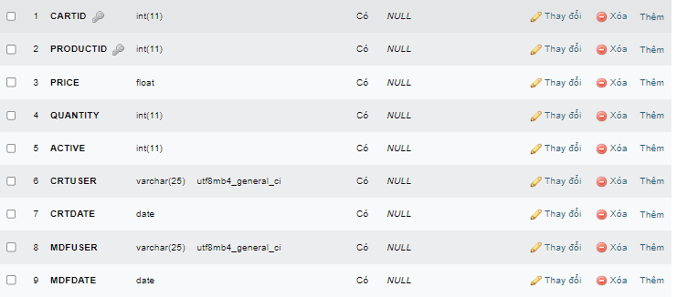

3.2.2.4. dimension

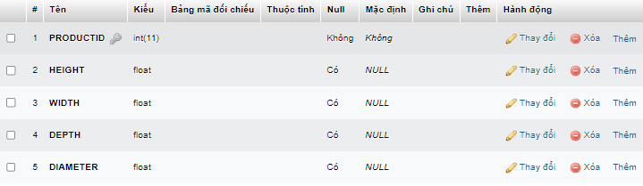

3.2.2.5. feedback

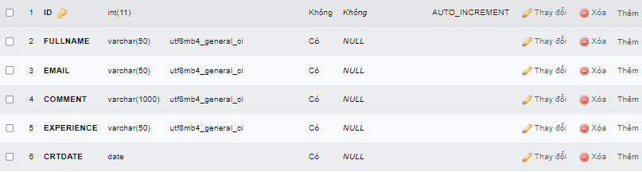

3.2.2.6. orders

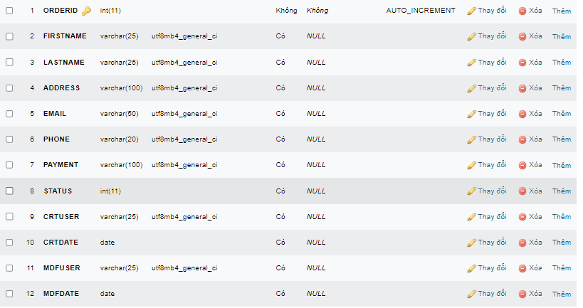

3.2.2.7. orderdetail

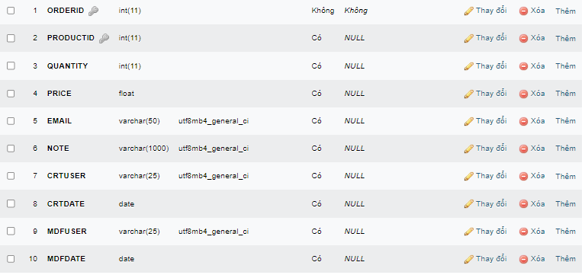

3.2.2.8. products

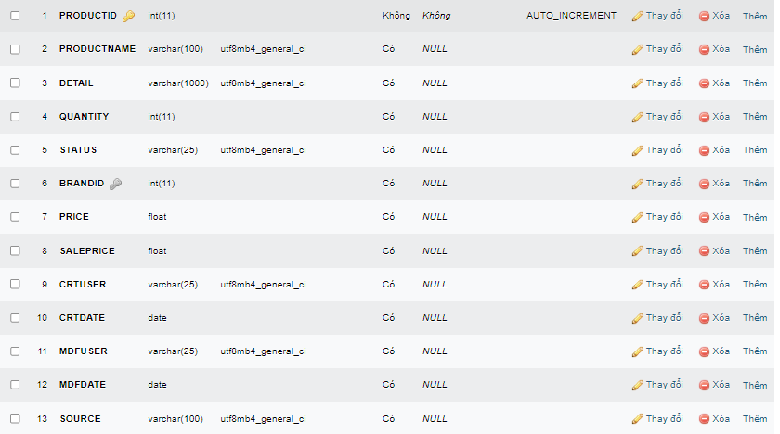

3.2.2.9. users

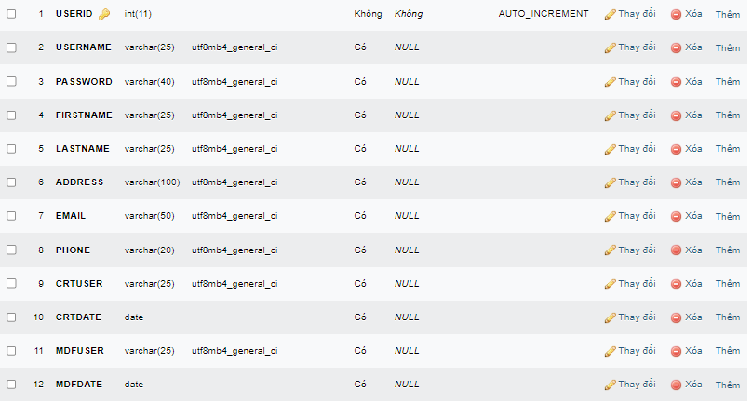

**3.3 Sitemap**

<Thiết kế sơ bộ giao diện tổng quát: trang chủ, liên kết với các trang trong ra sao?>

**3.4 System functions design**

<Chi tiết hoá các chức năng của hệ thống ở phần 2.2.

<Mỗi chức năng cần: thiết kế giao diện vào, ra, sơ đồ hoạt động, thuật toán giải quyết (bằng lời và bằng lưu đồ>

3.4.1.Register

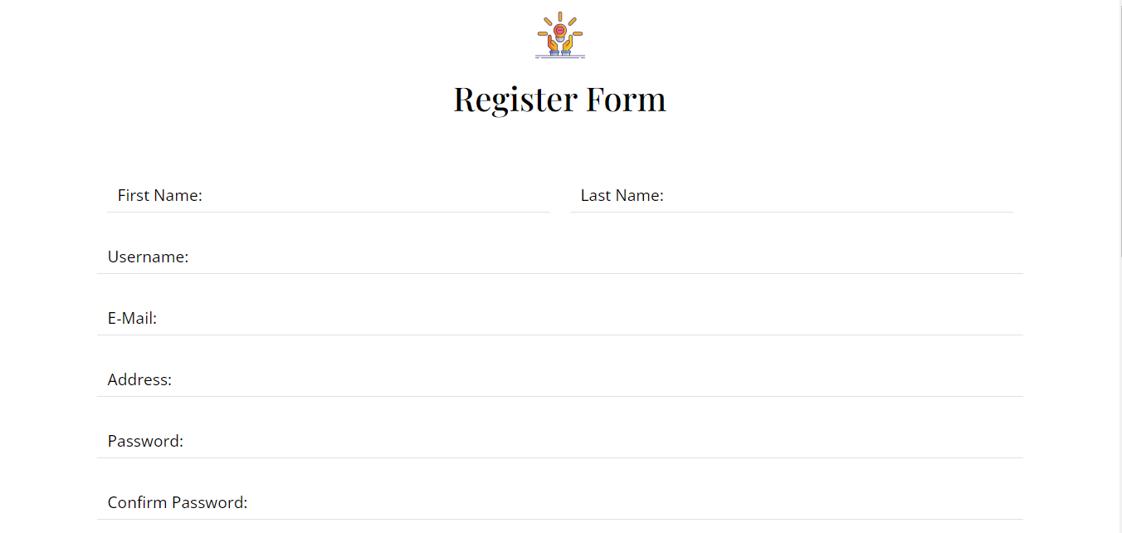

The users type their information in these blanks

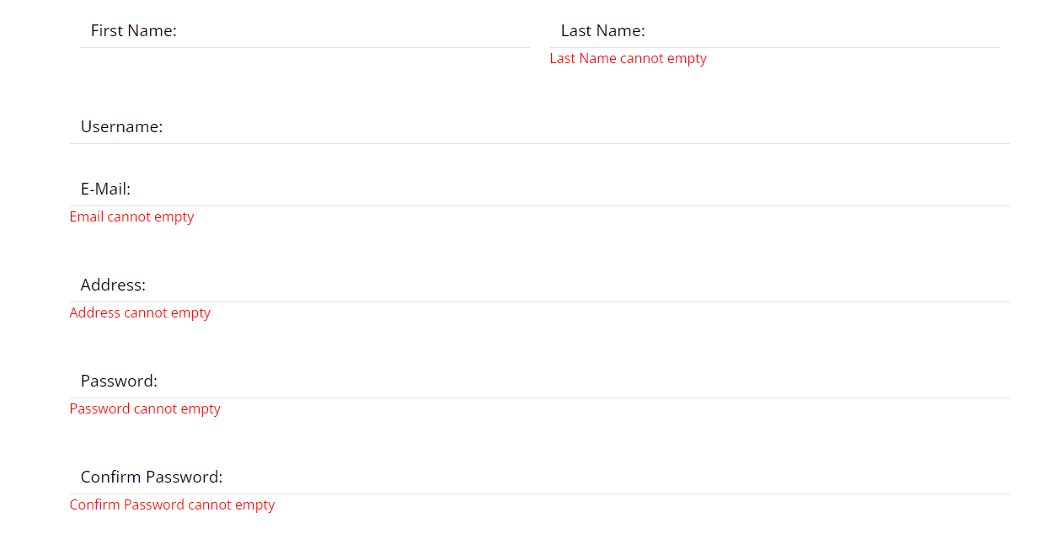

Error messages will appear when the user fills in the wrong format

Click on “Register” button to create an account

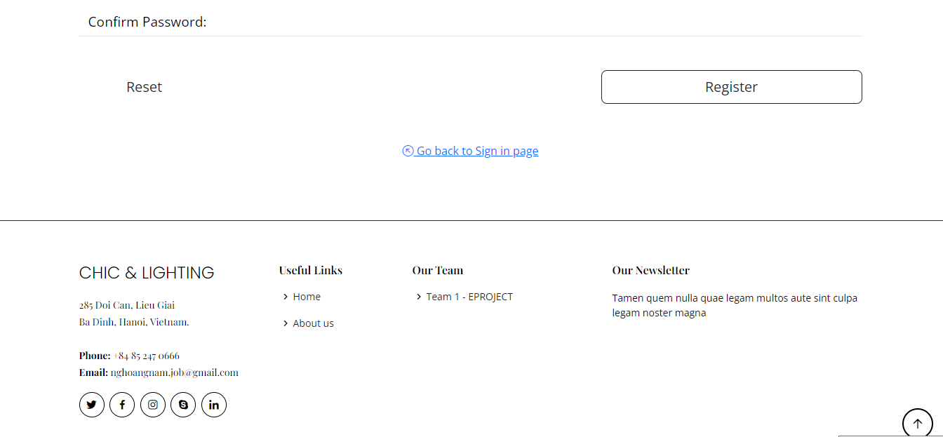

The user can change to login form if they’ve already had an account

3.4.2. Login

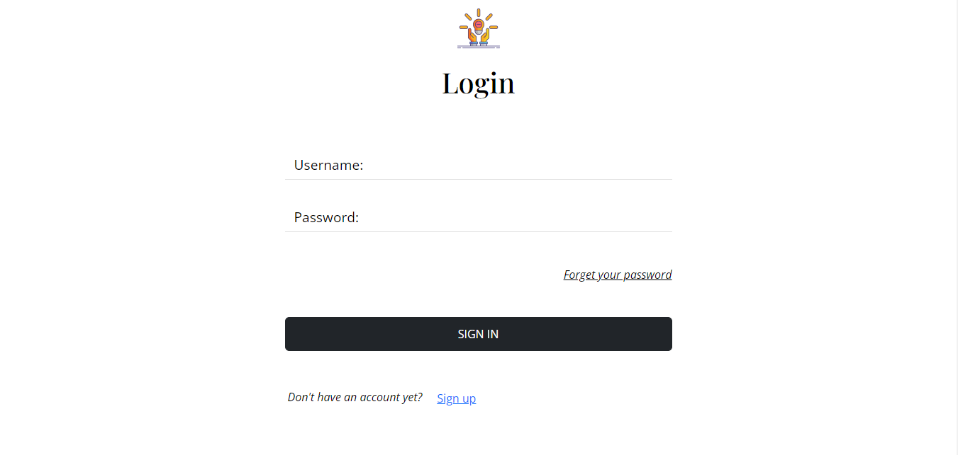

User enters their registered username and password

If the user enters the wrong username or password, an error message will appear

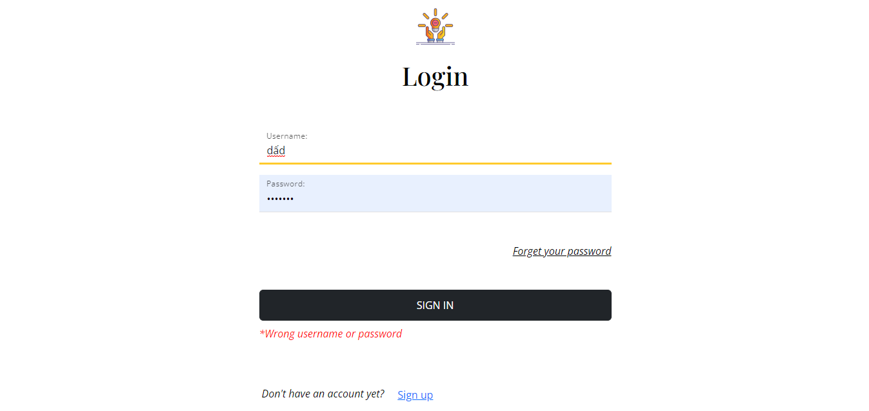

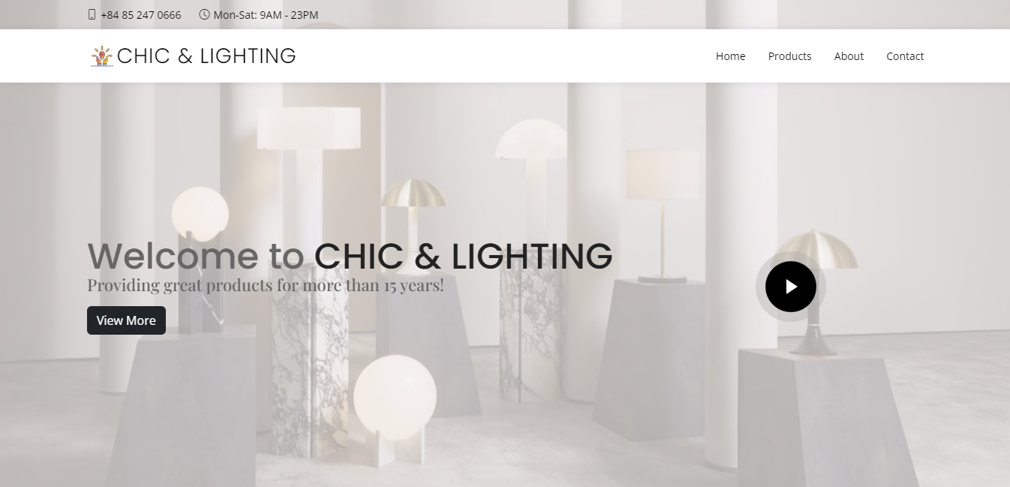

Link to About page

Link to Contact page

Link to Products page

when user successfully login, their screen will switch to home page

Product type slideshow

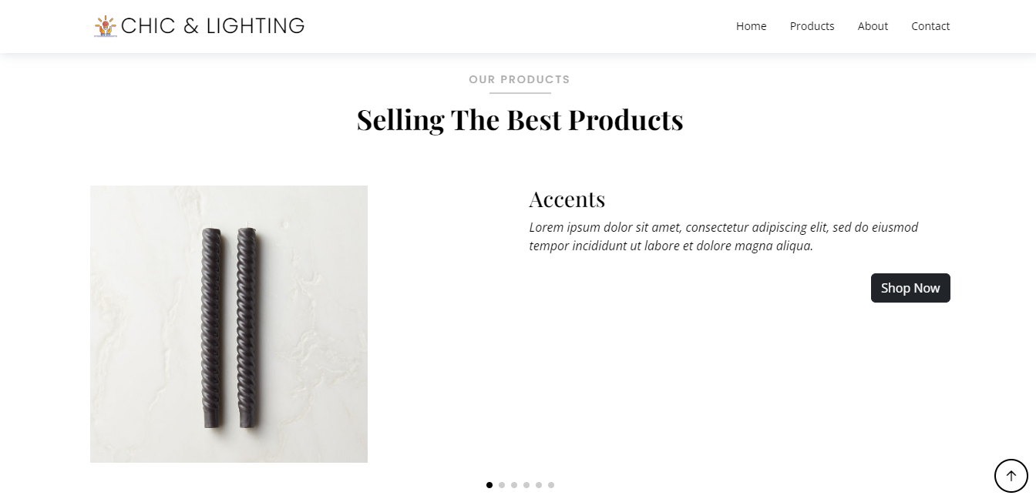

Link to Products page

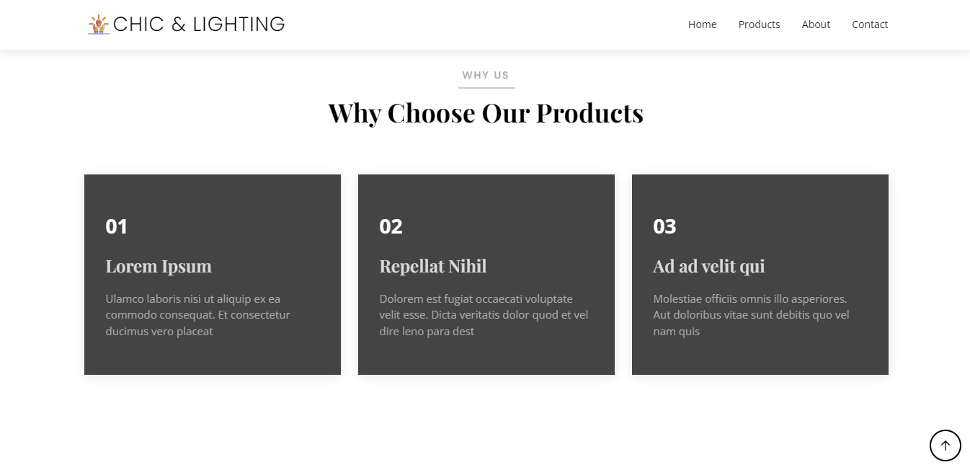

Some customer feedback

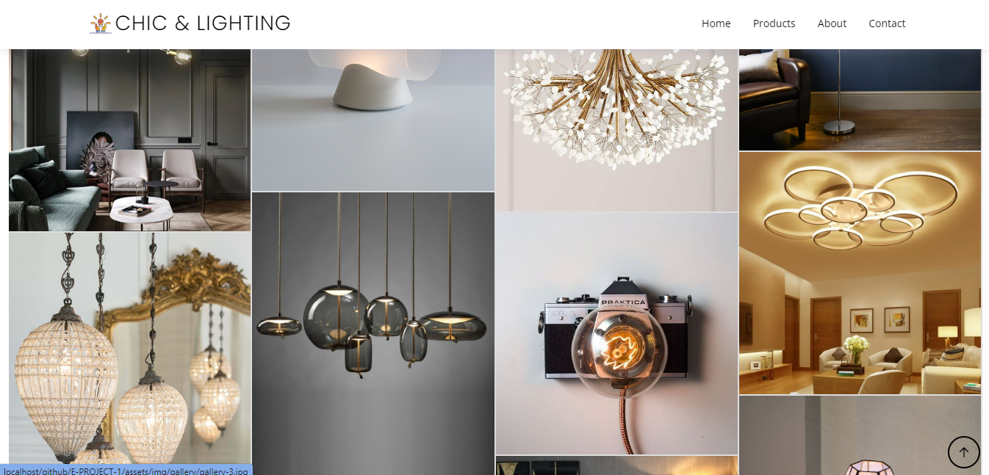

Some photo of our products

3.4.3. Feedback

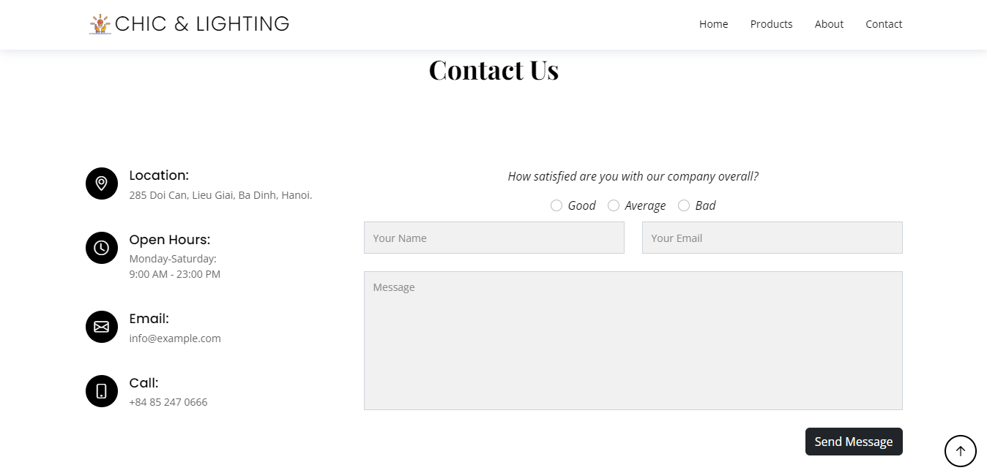

after entering feedback, click this button to submit feedback and the page will be reloaded

users enter their feedback

users rate their experience by clicking on one of these boxes

Our information

In contact page, the users can send feedback

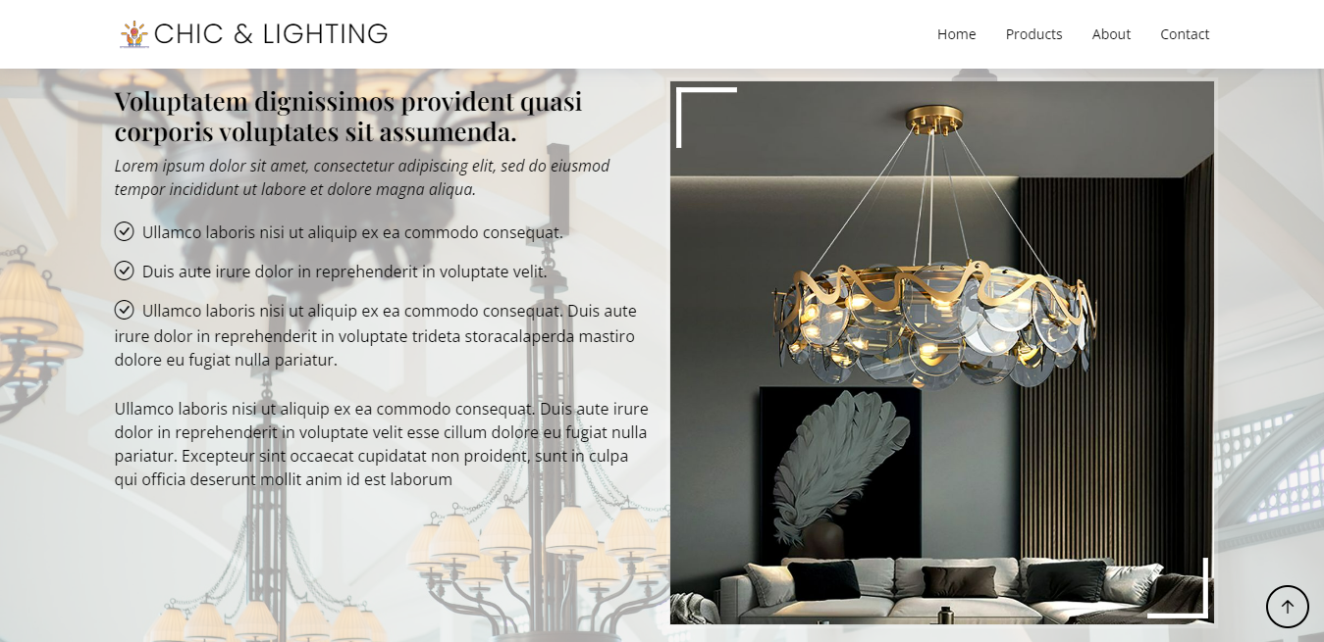

The about page contains more information about Chic and Lighting

3.4.4. Log out, change password. Search and add to cart

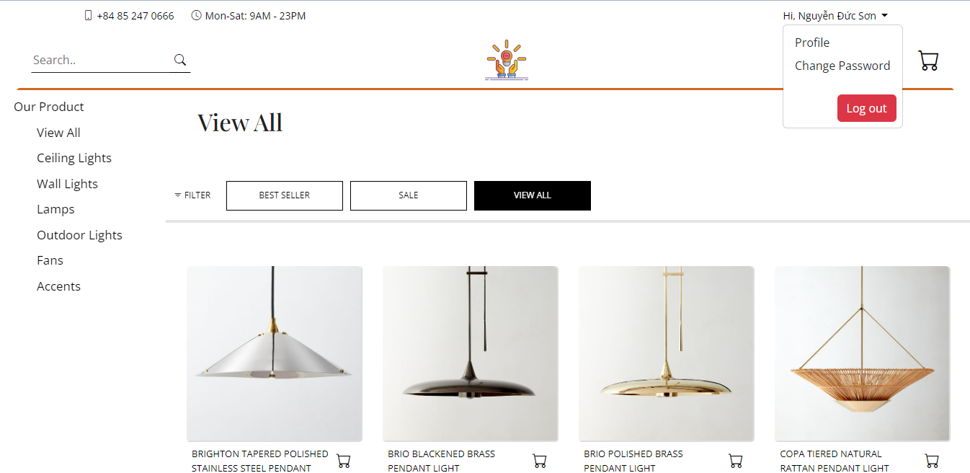

Click on the cart icon to add the product to the cart

product page when users have logged in

Enter product name or keyword to search product

View users’ cart

when the user clicks logout, the screen will return to the home page

View user profile

Change password

users can view cart only when they are logged in

when the user clicks on the logo, the screen will return to the home page

Link to login form

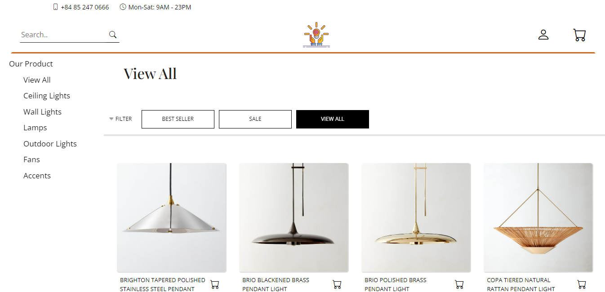

filter products by status

filter products by type

product page when users haven’t logged in

Click on the photo or product name to see details

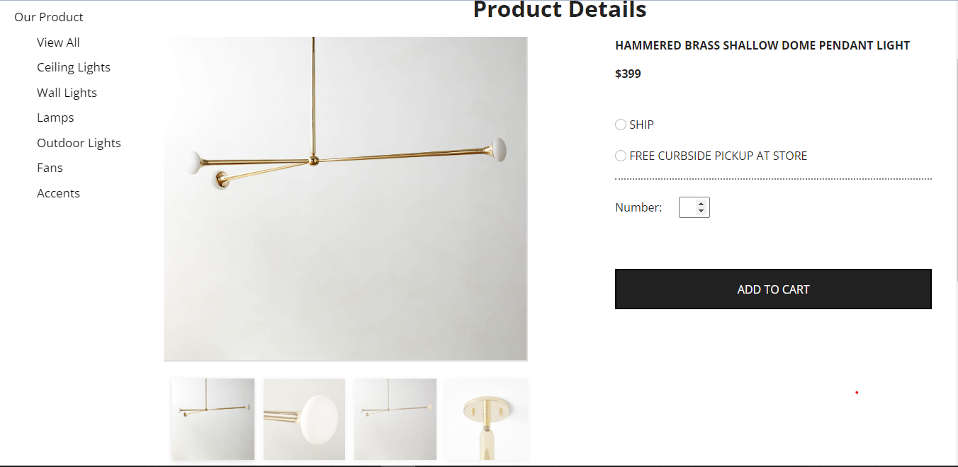

Choose number of products

Choose ship or pickup at store

Add to carts

Click on each of these small images to display on the screen

Product details

**4. Task sheet**

<Liệt kê các công việc cần thực hiện trong đó chỉ rõ sự phân công trách nhiệm và thời gian bắt đầu, hoàn thành. Nên kẻ bảng (tham khảo cuốn Project Guide đã được phát)>

**5. Validation Checklists**

<Tham khảo Project Guide>